1. **BUSINESS MODEL**

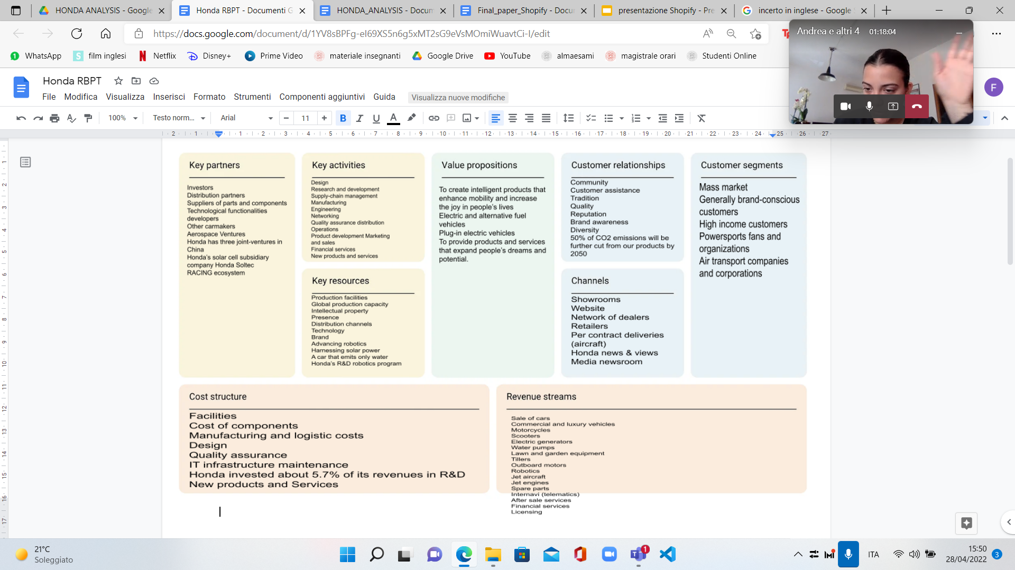

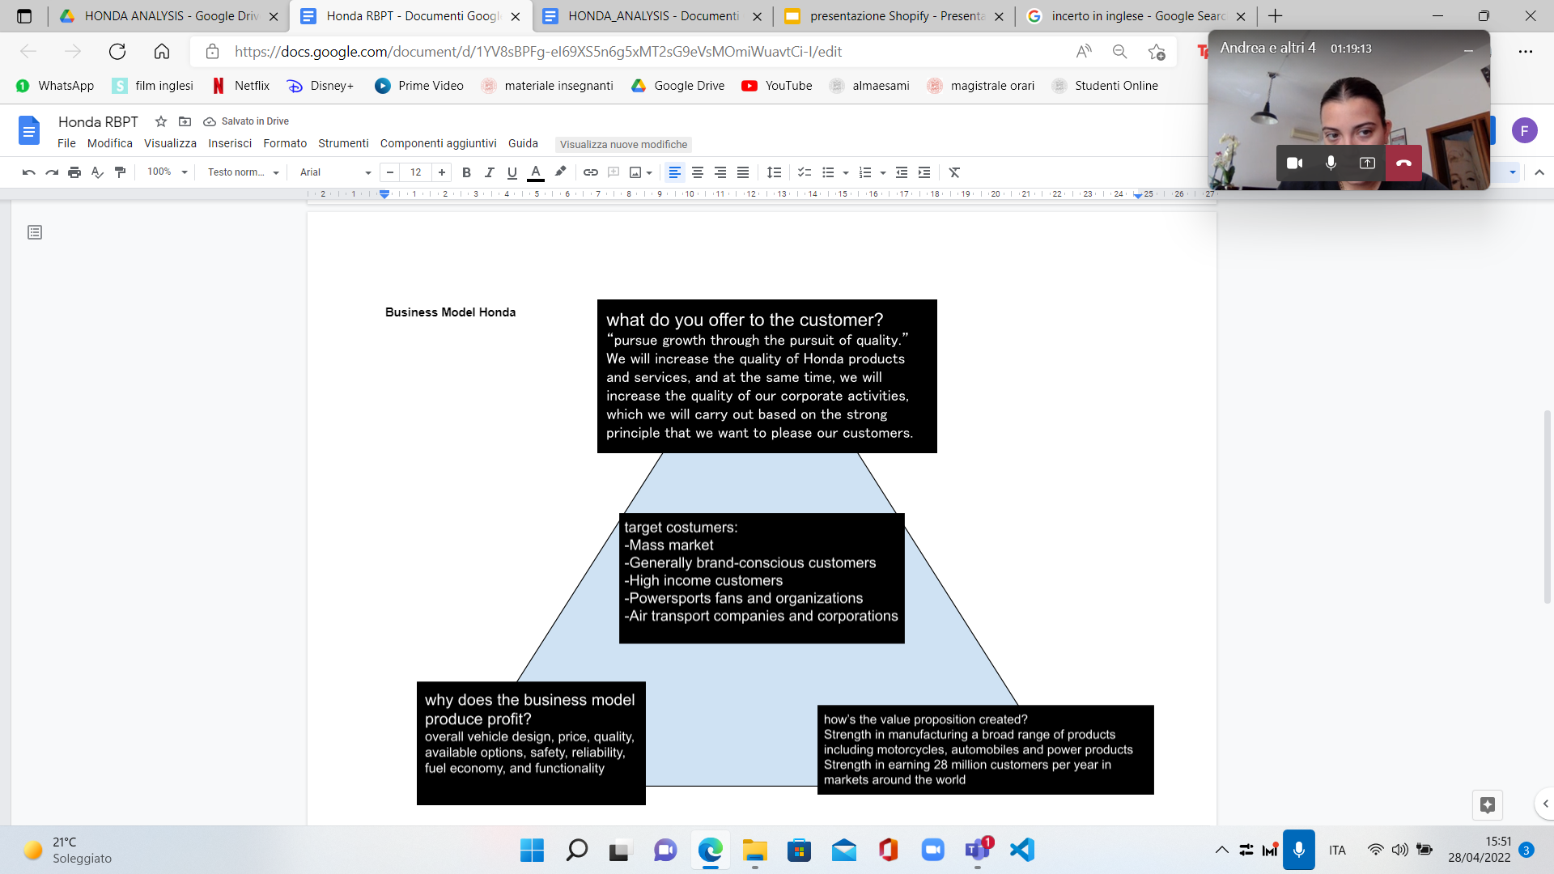

Honda Motor Co., Ltd. is a Japanese Public multinational conglomerate corporation primarily known as a manufacturer of automobiles, motorcycles and power equipment. Honda has been the world's largest motorcycle manufacturer since 1959, as well as the world's largest manufacturer of internal combustion engines measured by volume, producing more than 14 million internal combustion engines each year. Honda became the second-largest Japanese automobile manufacturer in 2001. Honda was the eighth largest automobile manufacturer in the world behind General Motors, Volkswagen Group, Toyota, Hyundai Motor Group, Ford, Nissan, and PSA Peugeot Citroën in 2011.

Honda believes in The Power of Dreams. But believing isn’t enough. As Soichiro Honda said: “Action without philosophy is a lethal weapon; philosophy without action is worthless.” See how we are bringing this idea to life.

Honda is in the business of moving you in every sense of the word. They create intelligent technologies that enrich lives and make the world more fun to move around in — on the road, on the water, in the air and beyond. Their driving inspiration will always be to enhance the joy and freedom of mobility for all.

1. **BUSINESS PERFORMANCE BREAK DOWN**



**COMPARISON WITH INDUSTRY (4 MAJOR COMPETITORS)**

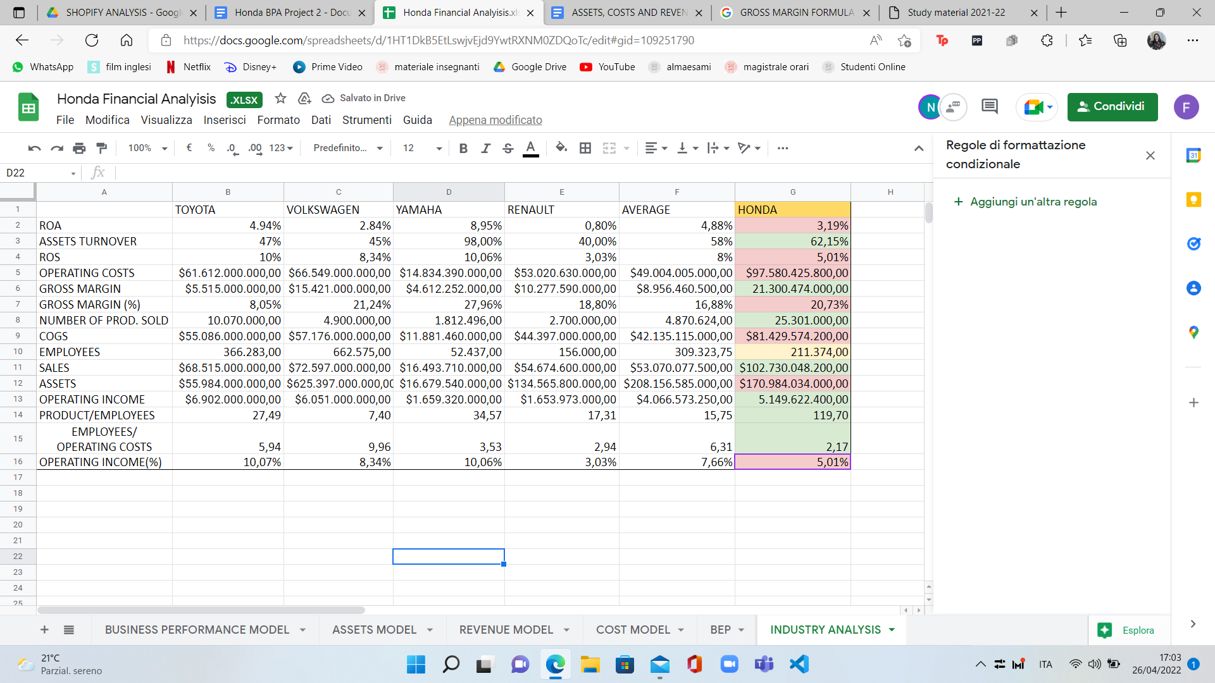

We started evaluating the performance of the company measuring the ROA, that assess how profitable a company is in relation to its total assets. The result is 3.19% that is lower than the average of the industry that we considered. But by taking a more specific approach we can see that only Toyota and Yamaha have higher ROA than Honda mainly because they are able to operate with a lower level of assets.

Then we evaluated the return on assets that measures the efficiency of a company's use of its assets in generating sales revenue or sales income to the company. Honda has a very good result with 62.15%, meaning that it has a very efficient management of its assets.

Slightly worse the result of ROS meaning that Honda has some problems in turning its sales into profit. Probably this is given by the fact that it has high costs which will be discussed later with the cost model. It is possible to see that in respect to the industry, operating costs are much higher (also considering the competitors one by one).

This is partially caused by a very high level of COGS. But it is also important to consider that Honda sells much more than its competitors and so a heavier cost structure may be physiologic. This is why we deepened the analysis evaluating a relative measure, the Gross Margin%, for which Honda shows a result of 20,73% that is higher than the average of the industry.

The operating income level is in line with the other competitors while if we consider the operating income over revenues the result is slightly worse.

A key advantage of Honda might be measured by the Employees/Operating Cost ratio. This metric shows that Honda needs much less employees with respect to its competitors to manage 1 million dollars of operating costs. This is a clear sign of greater production efficiency.

Overall it is possible to notice that the key distinction feature of Honda is the ability to sell many more products then its competitors. But this ability is not sided by an equally good ability to turn this additional production into increased profitability. Presumably if Honda could lower its cost structure, it could greatly improve its profit results.

**REVENUE MODEL**

Honda Makes money with four different business segments:

* Motorcycle Business: The principal products for the business would be: Motorcycles, all terrain vehicles (ATVs), side by sides (S×S) and relevant parts. The functions can be categorized as Research and development, Manufacturing and Sales and related services.
* Automobile Business: The principal products for the business would be all kinds of cars, vans and relevant parts. The functions can be categorized as Research and development, Manufacturing and Sales and related services.
* Financial Services: The segment provides financial services for purchasing or leasing vehicles of the company.
* Life Creation and Other Business: The principal products for the business would be power products, its relevant parts and others. The functions can be categorized as Research and development, Manufacturing and Sales and related services.

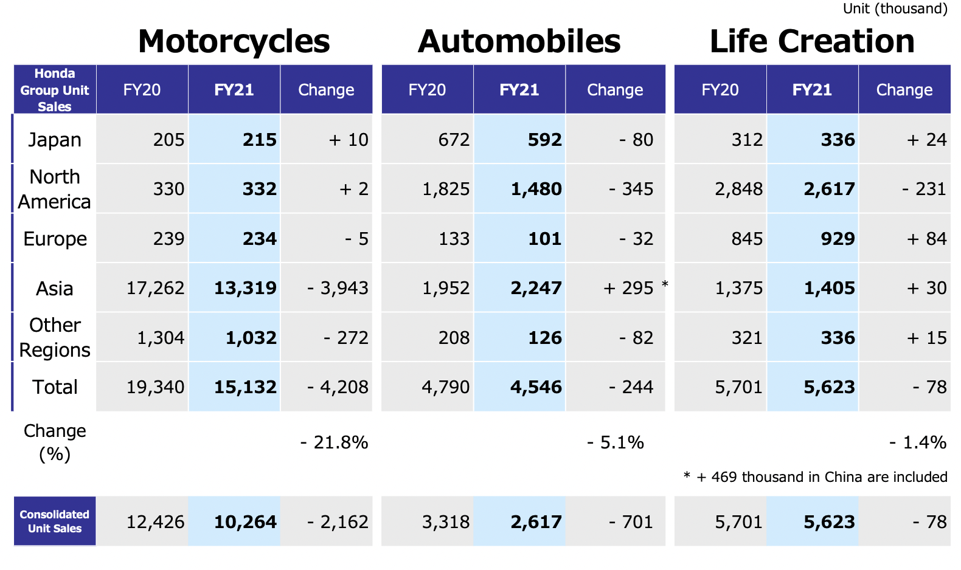

Honda sold a total of more than 25 millions units of product for a total of 102 billions of dollars.

The most important markets are Japan, North America, Asia (trained mainly by China) and Europe.

Regarding 2021 results, these have been driven by the industry demand fluctuations.

Automobiles: the industry demand lowered with respect to 2020 in Japan due to the impact of Covid 19 and U.S.A., despite the gradual recovery of economic activities since May. The demand increased instead in China, due to the effect of various consumption stimulus measures taken by the government.

Honda sales decreased in Japan, despite the strong sales of the N-BOX series. In the U.S.A. Honda maintains equivalent recovery as the market due mainly to the strong sales of CR-V and Pilot. In China Honda Achieved historical record high sales due to strong sales of Breeze, CR-V, and Vezel as well as expansion of xEV lineup to main models.

Motorcycles: The Industry demand has been lower than last year. Recovering in countries like China and the United States. Asia, the largest market, has been recovering moderately.

Honda demand also has been lower than last year. India recovered to the equivalent level as the same period last year from the 3rd quarter. Indonesia recovered to YoY 83% in the 4th quarter. China and Pakistan exceeded last year.

Operating Profit: Despite the demand decline caused by COVID-19 and impact of the semiconductor supply shortage, improvement in SG&A efficiency and cost reduction efforts caused by continuous review of the business operation as well as difference in the amount of the provision for credit losses in the financial services business contributed to surpass operating profit last year, achieved 660.2 billion yen.

Profit for the year: Due mainly to the increase in share of profit of investments accounted for using the equity method, achieved 657.4 billion yen.

SALES REVENUE/ OPERATING PROFIT (MARGIN) BY BUSINESS SEGMENT FY 2021

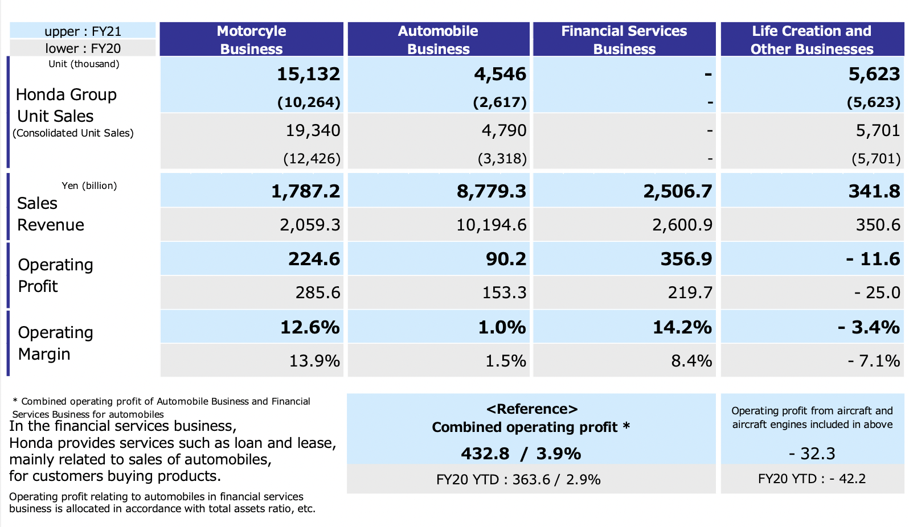

SALES REVENUE/ OPERATING PROFIT (MARGIN) BY GEOGRAPHICAL AREA

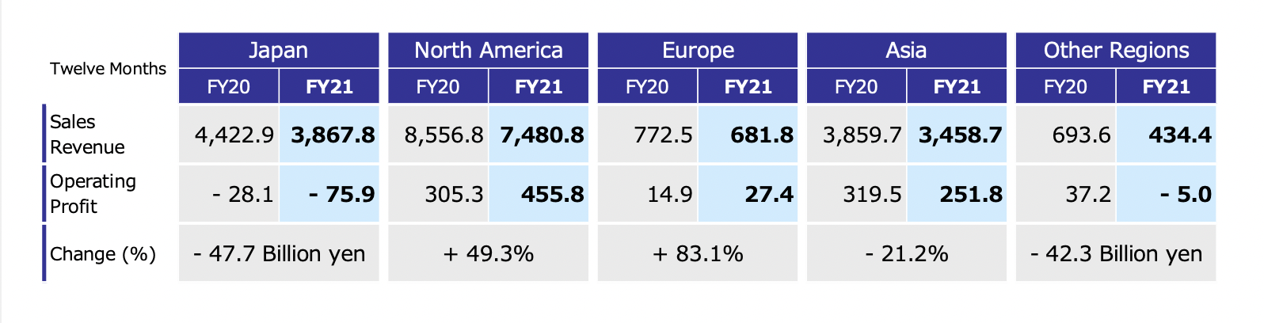

It is important to notice that despite being the greatest in the level of sales, the Automobile Business is the less profitable one. The motorcycles business is much more profitable, with an Operating margin of 12,6%. This might suggest to Honda that for the next few years a different product mix, that will enhance the motorcycle segment, might be a good choice to improve the overall results.

Japan performed really badly in 2021 but this is caused mainly by the COVID 19 impact and it should not be a problem in the next few years. Europe showed a good increase, meaning that it can represent a region in which the company can find itself in a growing phase of the business lifecycle.

THE TREND

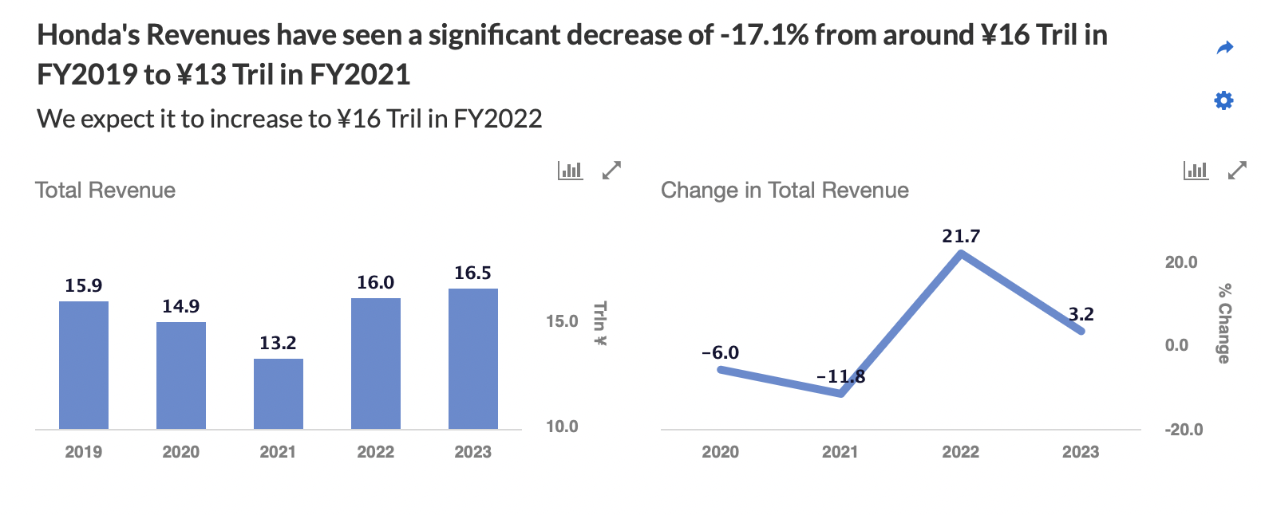

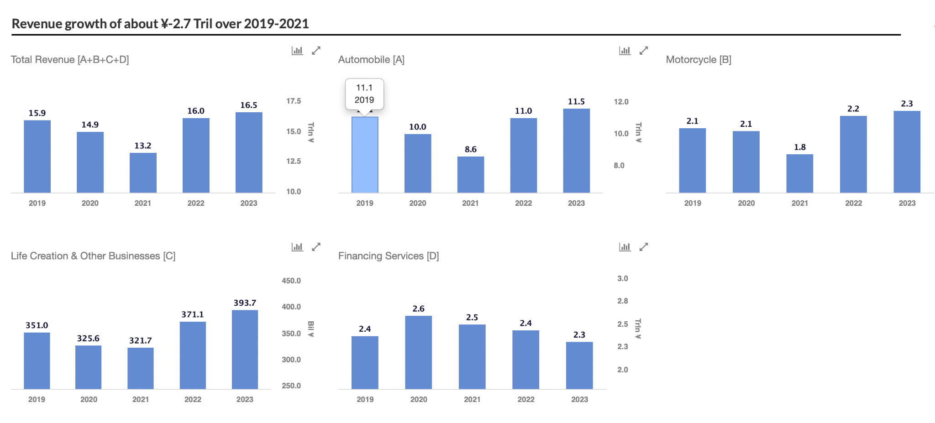

2021 was a worse year than previous years. Nevertheless, the company and analysts are confident that in the near future Honda will be able to return to previous levels. This is because the worst results were driven by transitional factors. In addition, Honda's efforts to reduce costs will certainly lead to better results.

**COST MODEL**



As it normally goes we have higher costs for operating activities than non-operating ones, so let's analyze the operating costs.

We have found a pretty low value for the indirect costs which comprend the Leasing costs for machinery and structure, the selling, general and administrative costs (marketing, costs for energy, water ecc.) and research and development.

More direct costs are instead very high (as already anticipated in the previous comment) as common for a manufacturing company. One of the most interesting findings stands in the Labor costs in which (see excel) we can see that they have a high cost for training which is actually a value adding cost, this proved by the fact that every employee has in average a much higher number of products produced in a year. We then have the raw materials cost and the expensive and amortization costs that are pretty standard.

As a final consideration (considering both the business performance break down and the cost model) we can say that in general what could be improved is the use of leasing as a tool to reduce the expenses and amortization costs, also we advice to keep up the training of the labor force but to improve that cost structure by finding new, more efficient ways of training and last but not least an improvement of the marketing (SG&A) plan could really drive the sales up by also driving the operating profit up at the same rate.

Citing their own Business plan: “Despite the demand decline caused by COVID-19 and impact of the semiconductor supply shortage, improvement in SG&A efficiency and cost reduction efforts caused by continuous review of the business operation as well as difference in the amount of the provision for credit losses in the financial services business contributed to surpass operating profit last year, achieved 660.2 billion yen.”

In conclusion, an improvement in the cost structure is crucial to the better performance of Honda.

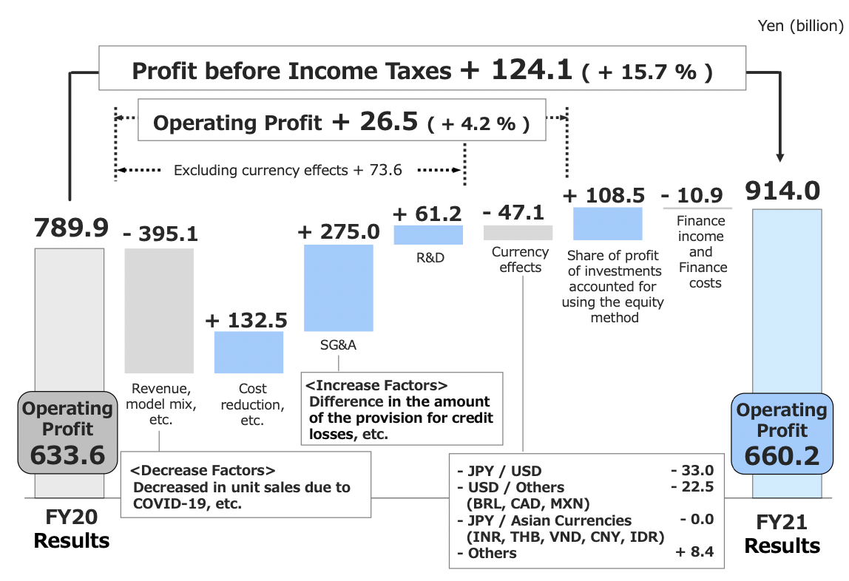

**ASSETS MODEL**

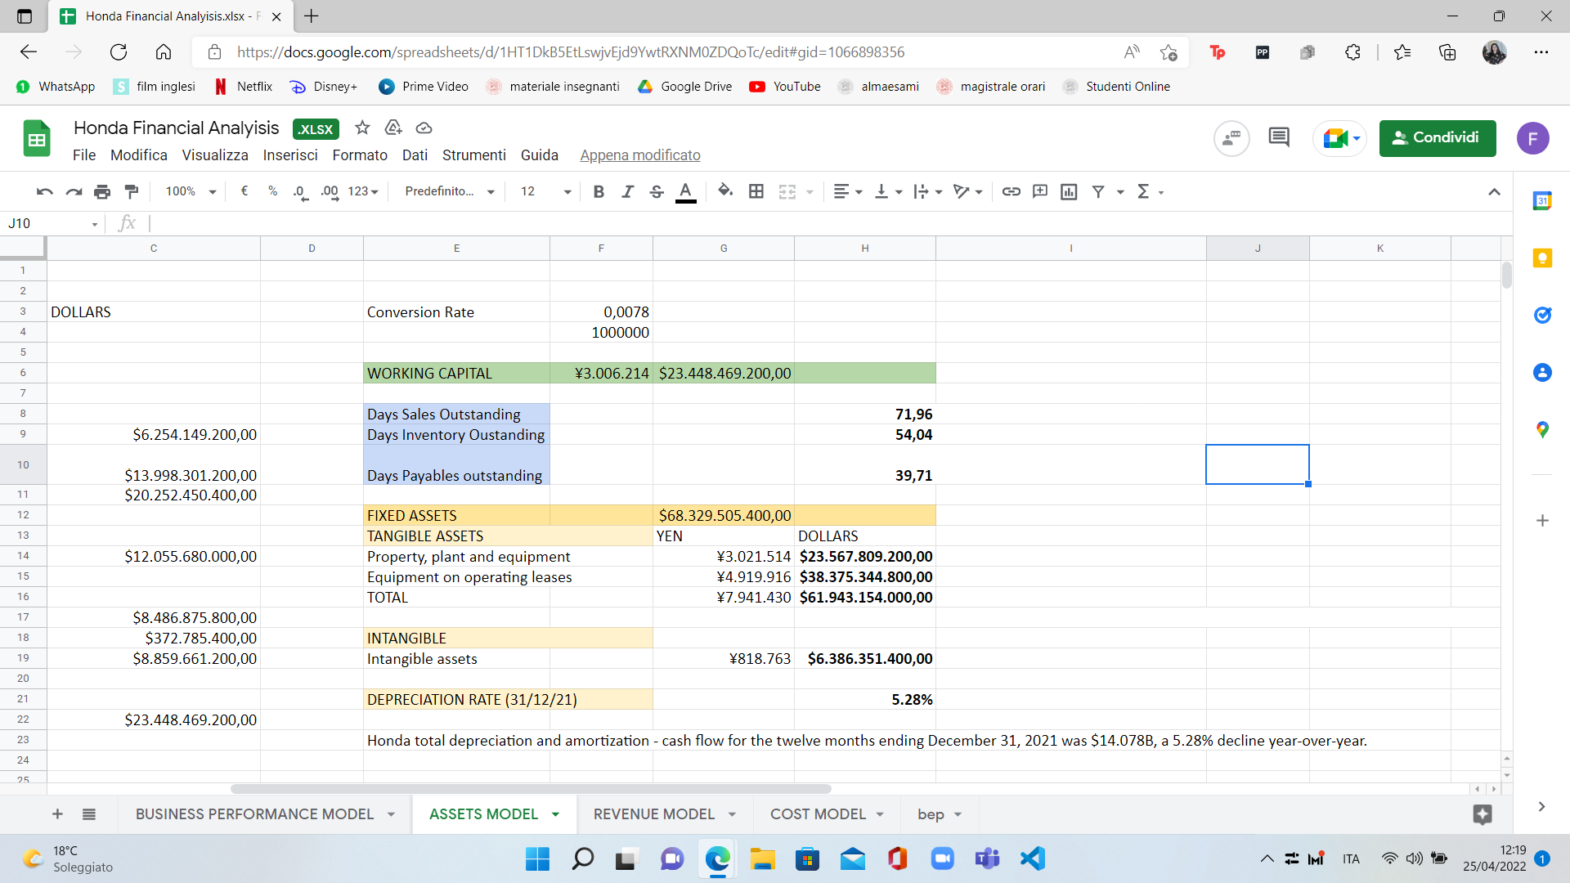

As noted above, Honda is able to produce many more products than its competitors while operating with a level of Assets that is in line with the average. This means that Honda pays a lot of attention to asset management. Unfortunately this ability is mitigated by the heavier cost structure. This is why the ROA level is not higher than competitors.

The working capital structure seems quite troubling and if not corrected in the near future could lead Honda to adopt a more expensive coverage policy than it currently has.

It is possible to notice that the DSO (Days sales outstanding) and the DIO (Days inventory outstanding) are both greater than DPO (Days payable outstanding).

This means that Honda on average is paid by its customers every 71 days while it pays its suppliers every 39. This means that the spontaneous source of financing generated by the Payables might not be able to cover the financial needs generated by the Receivables.

This might lead the company to finance its operative debt with honorous sources of financing like financial debt or equity.

**BREAK-EVEN POINT**

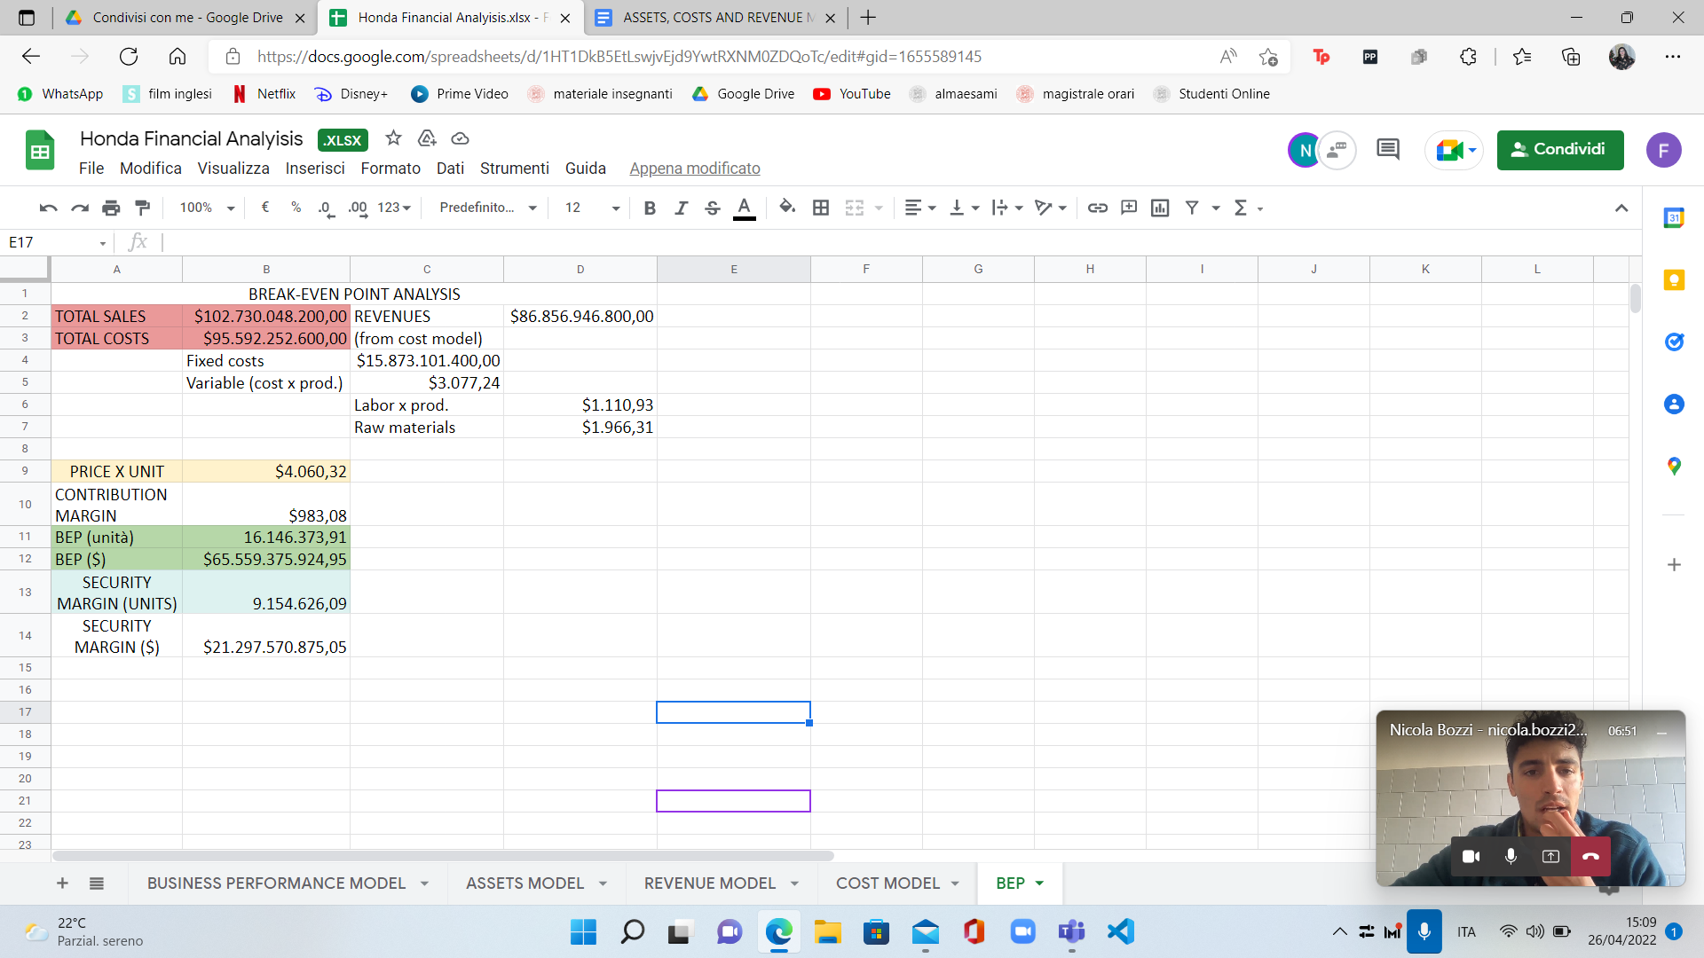

We evaluated the break-even point by first calculating the average price per unit (by doing sales/number of products sold) and then by calculating the contribution margin (price per unit - variable cost per unit).

The findings are really reassuring as the units sold to reach the point of equilibrium are far better with a security margin of 9.154.626 units which in a general vision gives Honda a strong secure and efficient structure.

1. **BUSINESS ANALYTICS AND DIGITAL PLATFORM ANALYSIS**

**Customer Behavior Analytics**

Honda works to maximize customer satisfaction. Every step of the way, from purchase to after-sales service, is focused to earn and maintain the trust of customers.

As stated in Honda's 2020 vision, the Customer Service Operations is striving to realize optimal service operations in markets worldwide to pursue the priority goal of creating and expanding customer joy worldwide through service.

Honda aims to create customer joy and excitement by providing a level of value that not only satisfies the expectations that customers have when they receive services based on their past experiences and information, but also exceeds them. The experience of excitement through these services forges an emotional connection between customers and Honda, ensuring that the company remains a mobility manufacturer that customers choose based on their high expectations.

To attain this goal, services and parts divisions have adopted an activity policy of offering service in a friendly, timely, reliable, affordable, and convenient manner; developing an advanced service environment; and maximizing business efficiency and expanding business operations.

Aiming to establish lifelong relationships with satisfied customers, Honda takes a proactive approach to conducting customer satisfaction surveys in all product segments: motorcycles, automobiles, and power products.

The Customer Relations Center of Honda has a very straightforward slogan: "For the customer." Its mission is to handle inquiries from customers politely, clearly, and quickly, delivering the same high quality in Honda communications as is found in Honda products.

The Center receives feedback in the form of customer questions, suggestions, requests and complaints 365 days a year. To ensure that this valuable information is put to good use in Honda's operations, the facility shares it in a timely manner with the company's R&D, manufacturing, service, and sales departments in compliance with laws and regulations as well as Honda's own policies concerning the handling of personal information.

**Marketing Mix Analytics**

Marketing Strategy of Honda analyses the brand with the marketing mix framework which covers the 4Ps (Product, Price, Place, Promotion). Honda marketing strategy helps the brand/company to position itself competitively in the market and achieve its business goals & objectives.

## Honda Product Strategy: It has 4 business segments: automobile, motorcycle, financial services and power.

## Honda Price/Pricing Strategy: These automobiles target customers from low middle income level to high income level. Dealerships have limited flexibility over pricing.

## Honda Place & Distribution Strategy: Honda has a robust sales network. This shows the strong marketing mix distribution strategy of Honda motors.

## Honda Promotion & Advertising Strategy: Honda used an innovative marketing campaign to change the way customers perceived motorbikes.

**Supply Chain Optimization Analytics**

From FY2018, Honda is taking part in CDP’s supply chain program (an international initiative by institutional investors requesting companies for disclosure of information on climate change policies) and requesting disclosure of risks and opportunities related to Greenhouse Gas (GHG) emissions and the environment from suppliers in addition to information on matters relating to Honda’s operational domains.

Honda is working to improve transportation efficiency in the shipping of vehicles and equipment, parts shipped between plants, parts for services and repairs, and parts collected from suppliers. In addition to this, in FY2017 the Company commenced management of CO2 emissions in the transportation of automobile production parts, which make up the majority of international marine transport.

Honda’s goal is to achieve a sustainable society across the supply chain. The Company implements initiatives with consideration for the environment, safety, human rights, compliance and social responsibility, among others, in partnership with its suppliers worldwide.

Honda defined points of concern that it should follow, in particular, as the Purchasing Code of Conduct, and by following this Code, the Company enhances trust with related divisions and business partners as well as builds sound relationships with suppliers.

**Predictive Quality Analytics**

Honda uses Predictive Analytics to shift Profitability into High Gear. Honda exploits the advantage by using the power of machine learning, the Internet of Things (Iot) and predictive analytics by relying on Splunk, that turns data into action and predicts wear and tear of machinery to safely and efficiently produce more than 3,400 vehicles every year.

**DIGITAL PLATFORMS: Twitch and Qlik**

**Twitch**

Honda was the first major car brand with a dedicated Twitch gaming page called Head2Head, with the hope that, by advertising on social platforms, it could reach a younger audience, as well as promote newer models that are more popular among younger shoppers, like electric shoppers.

The Civic is the number one vehicle with “Millennials and Gen Z [as well as] first-time and multicultural buyers, given that it is one of Honda’s cheaper vehicles, with a starting listing price of $22,000. Sixty seven percent of Twitch’s audience is under 35 and Honda views the model “as a gateway” to longer-term brand loyalty and higher-priced future purchases.

**Qlik**

Qlik is a software vendor specializing in data visualization, executive dashboards and self-service business intelligence products. Honda is using Qlik to streamline business processes and establish a company wide data culture.

With the use of this software, Honda aims to:

* Reduce production costs, more efficient business operations
* Create a companywide data culture with thousands of Qlik users
* Reduce the time to prepare materials from months to a single day

1. **FINAL CONSIDERATIONS**

In general we can say that Honda is an international, strong company that in the years really had some challenges and that was able to overwhelm other big players (like harley davidson) by becoming a leader of the industry. We analyzed the company by taking into consideration income statement, balance sheet and business plan (2021), also comparing it with the competitors mentioned above, and we can state that Honda is “playing” very well and very efficiently.

All our considerations are based on the data provided directly by the company.

Honda revenues have slowed down in the last year but this is just a conjuntural situation due to causes that are external to the company. In the next few years the revenues are forecast to grow again. In particular Honda might increase its presence in Europe where the growth possibilities are very important.

Regarding the business segments, the most profitable is the Motorcycle one. The diversification started by Honda introducing the Life Creation and financial segment is not producing the expected results but in the near future things should turn for the better.

Honda is good in operating with a level of Assets that is lower than the ones of the competitors of the same size. This gives to the company a competitive advantage that is, however, dampened by the heavy cost structure.

The Working Capital management should be improved trying to work on the ability of the company to collect money in a shorter time. Also, reducing the level of the inventory will surely increase the profitability performance of the company.

Regarding costs, the only valid consideration we have is on the cost structure and how it needs to be improved by working on the marketing segment and on the digital platform matter.